# Change request log

# Team

Group #5 (Inam and Pervez)

# Change Request

# FEMR-137: Flag birthdays as being accurate or a guess.

# Concept Location

Below table is to describe each step that we followed when performing concept location for this change request.

|  |  |  |
| --- | --- | --- |
| Step # | Description | Rationale |
| 1 | We ran the system |  |
| 2 | We Add a column in database patients table | In order to get to store the value for the birthday. |
| 3 | In patient POJO class we add a variable named age_flag and that is mapped to database column named "age_flag". | We will use this for transfer and getting value. |
| 4 | In DataModelMapper class we mapped and passed our pojo variable age_flag to the method named as createPatient in argument field, and then  we called the creation method. |  |
| 5 | We also create age_flag method in PatientItem class for the transfer the date and getting the data from UI. | We will use this value for the UI. |
| 6 | In SearchService implementation we also user age_flag variable in the list for calling and assign from service to dao injection. This  means we are passing the value and storing the value in database. |  |
| 7 | In controller class named as TriageController we are validation the age_flag variable, if the date of birth field has no specific  data value then it is assigning the default data of birth and assign value for age_flag is "Y" for the alerts in the screen. | Assign the value for age_flag if the date of birth is unknown. |
| 8 | In javaScript, if you enter age (integer years and months) then assign 'Y' value in age_flag |  |
| 9 | In index.scala.html we create a hidden input text field for the assigning the value for age_flag. |  |

**Time spent (in minutes):** 200

# Impact Analysis

|  |  |  |
| --- | --- | --- |
| Step # | Description | Rationale |
| 1 | We made changes in a method of the “Patient” class. | This fields will mapped with database. |
| 2 | Creating getting and setting method. | There is no impact for this change. |
| 3 | We made changes in DataModelMapper, for creating user. | There will be an impact for this change, if some other class call this method will require to pass another variable called age_flag |
| 4 | We also made a hidden input variable for getting the value. | This change has no impact |
| 5 | In service layer class, we will also add an age_flag variable in the list and inserting value for the passing value in the database. | There is no such impact but if we called the list then it will also contain the age-flag variable. |

**Time spent (in minutes):** 120

# Actualization

Using the table below, describe each step you followed when changing the code. Include as many details as possible, including why classes/methods were modified, added, removed, renamed, etc.

|  |  |  |
| --- | --- | --- |
| Step # | Description | Rationale |
| 1 | We modified patient class. | We add one variable, age_flag and also create setter and getter method. |
| 2 | We add one column in the database. | To store the value in the database. |
| 3 | We made changes in DataModelMapper in createpatient method. | To create a user with age_flag value. |
| 4 | We add variable in PatientItem | For the UI model data |
| 5 | We made changes in SearchService | We add age_flag variable in the methods. |
| 6 | We made changes in javascript | if user enter age (integer years and months) then assign 'Y' value in age_flag |
| 7 | We made changes in index.scala.html | For assigning value for age_flag. |

**Time spent (in minutes):** 75

# Validation

Using the table below, describe any validation activity (e.g., testing, code inspections, etc.) you performed for this change request. Include the description of each test case, the result (pass/fail) and its rationale.

|  |  |  |
| --- | --- | --- |
| Step # | Description | Rationale |
| 1 | Test case defined:  Inputs: year has value and month has  Expected output : flag should assign value “Y” | This is main regular requirement to check, date of birth is not known.  The test passed. |
| 2 | Test case defined:  Inputs: date of birth field is not empty  Expected output : flag should assign value “N” | This is an exceptional behavior, will store the date of birth of patient in the database and assigning the value “N” for age_flag  The test passed. |

**Time spent (in minutes):** 60

# Timing

Summarize the time spent on each phase.

|  |  |
| --- | --- |
| Phase Name | Time (in minutes) |
| Concept location | 200 |
| Impact Analysis | 120 |
| Prefactoring | 0 |
| Actualization | 75 |
| Postfactoring | 0 |
| Verification | 60 |
|  |  |
| Total | 455 |

# Reverse engineering

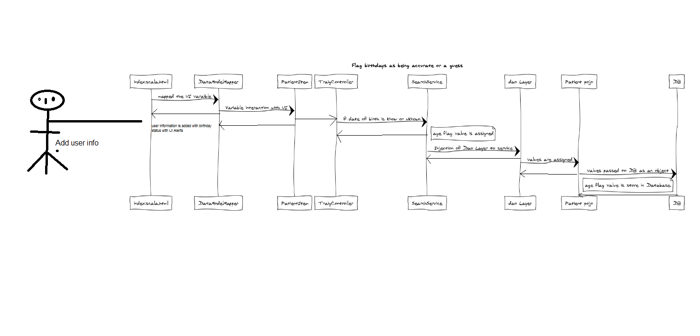

# Conclusions

Regarding this fix, we change below method from UI Patient class, DataModelMapper class, searchSercice class, PatientItem class, java script and index.scala.html